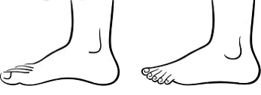




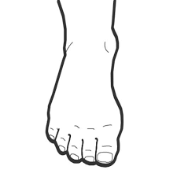
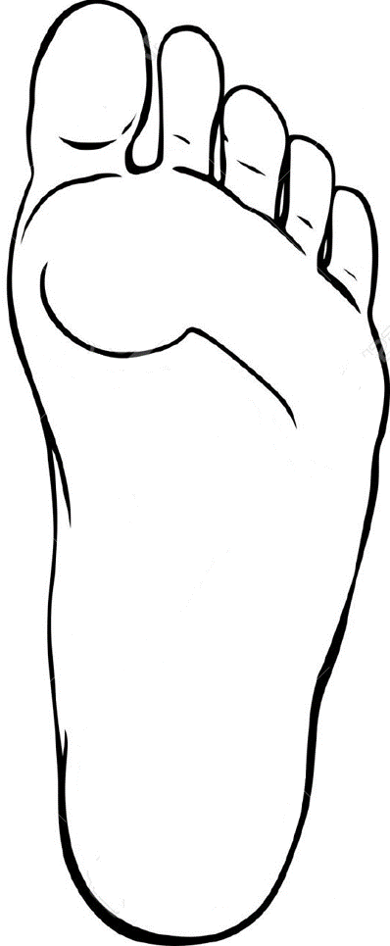



A
S
A
S
P
O
Date:_______________
Date:_______________
RIGHT
LEFT
KEY: X Crunch O Pop Swollen P+ Pain T+ Tenderness Z+ Energy # Dry skin ≈ Lines
P
O
RISK ASSESSMENT:

CONDITIONS:

1st IMPRESSIONS OF FEET:

PRIORITIES FOR NEXT TREATMENT:

Q’s TO ASK:

MEDICATIONS & SE’s

PERSONAL NOTES

RISK ASSESSMENT:

CONDITIONS:

1st IMPRESSIONS OF FEET:

PRIORITIES FOR NEXT TREATMENT:

Q’s TO ASK:

MEDICATIONS & SE’s

PERSONAL NOTES

